CLINICAL INTERVIEW FORM

Name________________________________________________________ Date_____________

General Questions
1. What brought you here?

2. How long have you had this symptom(s)?

3. What symptoms do you have right now (at the moment of interview)?

4. When and how did everything start?

5. Have you seen anyone especially your physician and has any diagnosis already been established? Were any tests
(x-ray, MRI, ct, nerve conducting study, etc.) done?

6. What treatments, if any, were used?

7. Do any family members have similar problems?

8. Were other health conditions or medications eliminated by the primary physician as potential causes of the patient’s symptoms?

9. Have you experienced any previous traumas?

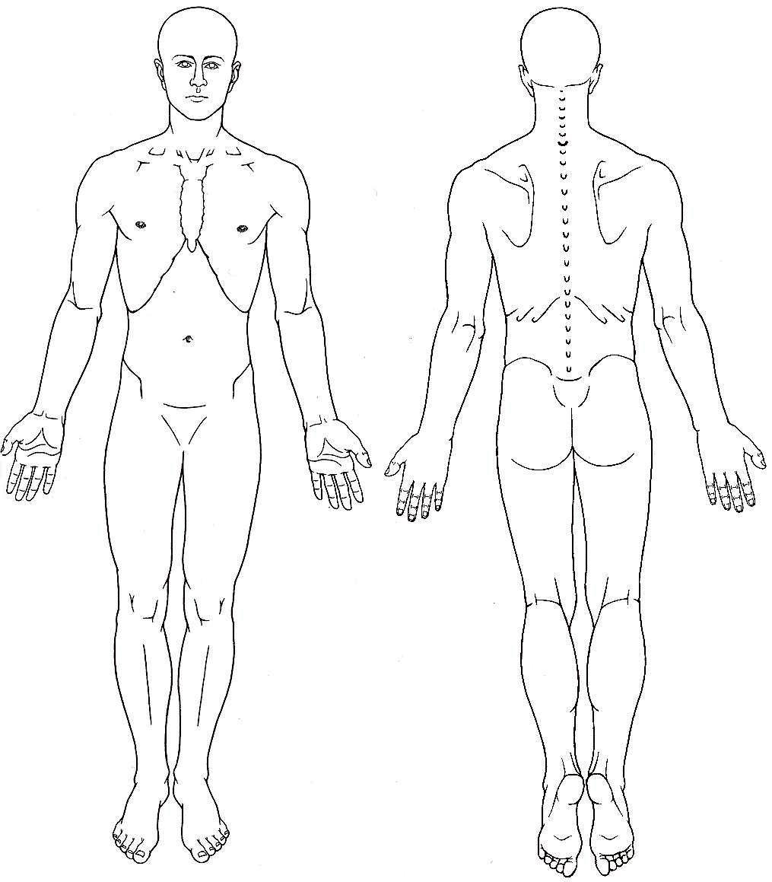Pain Evaluation

10. How would you describe the pain you have or had (mark on fig.1)?
◻ sharp ◻ aching ◻ burning ◻ pulsating

fig. 1

11. Do you feel pain locally? (fig.2)
Do you feel pain radiating to any neighboring part of the body?
◻ local radiation ◻ distant radiation

Do you have the sensation of spreading pain?
12. Did you notice if the pain you have is accompanied by:
◻  headache
◻  nausea
◻  sweating
◻  “goose bumps”
◻  changes in the body’s temperature
fig. 2
13. Did you have the sensation that the original pain triggers pain in other parts of your body? (fig. 3)
◻ radiating pain ◻ referred pain
- Do you feel rested in the morning after you wake up?
- Do you feel the pain is getting worse by late afternoon/evening?
- Do you have night pain?
Do you have difficulties falling asleep?
Do you wake up during the night?
- How is the pain you feel affected by your movement?
fig. 3
◻  movements increase pain intensity
◻  movements decrease pain intensity
◻  movements have no effect on the pain intensity
18. How do you grade your pain intensity on a 1-to-10 grade scale? 1 2 3 4 5 6 7 8 9 10

Evaluation Of Sensory Abnormalities
19. Have you had in the past or do you currently have sensations of tingling or numbness in any parts of the body?

Evaluation Of Motor Abnormalities
20. Do you feel any restriction in your rom? Do you feel any muscle weakness?

Notes

